Members of the Maple Shade Arts Council are highly important in the success of our programs. For $45, you will receive your membership for the Arts Council and two tickets to any of our adult musicals, valued at $30, or two tickets for our Children's Summer Theatre production. You will also have voting privileges in our General Membership meetings which will help decide our future programs. If signing up for additional family member, save $5 per membership for a total discounted rate of $80. Membership can be mailed to the address below or given to any board member.

Let us know your workshop idea or areas of expertise!

____________________________________________________________________________________________________________________________________________________________________________________________________________________________________________________________

Check areas of interest:

_____ Set Construction _____ Tickets

_____ Art Workshop Assistant _____ Ushers

_____ Concessions _____ Cleanup Crew

_____ Fundraising _____ Painting/Set Design

_____ Costumes _____ Create Own Workshop!

**Name of Member ____________________________________________________________**

**Additional Member __________________________________________________________**

**Address: ___________________________________________________________________**

**City: ____________________________________ State: ________ Zip: _____________**

**Email Address: _____________________________________________________________**

**Phone #: ______________________________________________**

**2 Free Tickets for summer musical or children’s summer musical (please circle one)**

Make membership check payable to: Maple Shade Arts Council

Mailing Address: MS Arts Council, PO Box 356, Maple Shade, NJ 08052

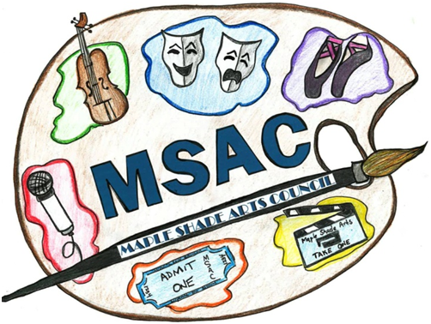

LOOKING FOR MEMBERS

FOR OUR 2016 SEASON!